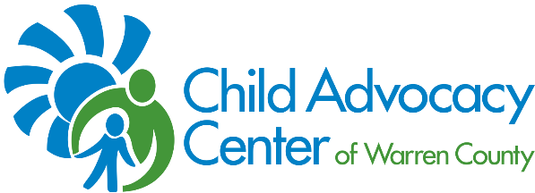

2020 PINWHEEL PARTNER
SIGN-UP AND REQUEST FORM
Contact Information
Name: Phone:
Agency/School/Business: Fax#:
Address: Email:

*Please fax or email this form to Amy Fornshell at (513)695-3120 or fornshella1@childrensdayton.org.
YES, SIGN US UP AS A PINWHEEL PARTNER FOR THE 2020 NATIONAL CHILD ABUSE PREVENTION MONTH CAMPAIGN!
We would like to do the following this April:
- Display Pinwheels or plant a Pinwheel Garden in honor of children. We would like_______ pinwheels. A donation of $1 per pinwheel is greatly appreciated.

- Place a CAC Change for Children container at your place of business, agency or school to collect change.

- Collect healthy snacks or supplies for use in our center for children during interviews.

- Have a Casual Ohio Wear Blue Day during which staff members can wear relaxed attire in exchange for a $5 donation on National Child Abuse Prevention Day in April and post a picture on the CAC of Warren County Facebook page.

- Invite a CAC of Warren County representative to talk to staff members about the issue of child abuse, child abuse prevention, and ways they can help keep children safe. Please contact Tova Rose at Roset@childrensdayton.org or (513)695-3100 to schedule a date and time.

- Sponsor a Stewards of Children training to educate your staff, friends, family, or faith community about child sexual abuse and how to prevent it. Contact Tova Rose at Roset@childrensdayton.org or (513) 695-3100 for more information.

